____________________________________________________________________________
CULN PROGRAM ASSESSMENT REVIEW
2015 - 2016
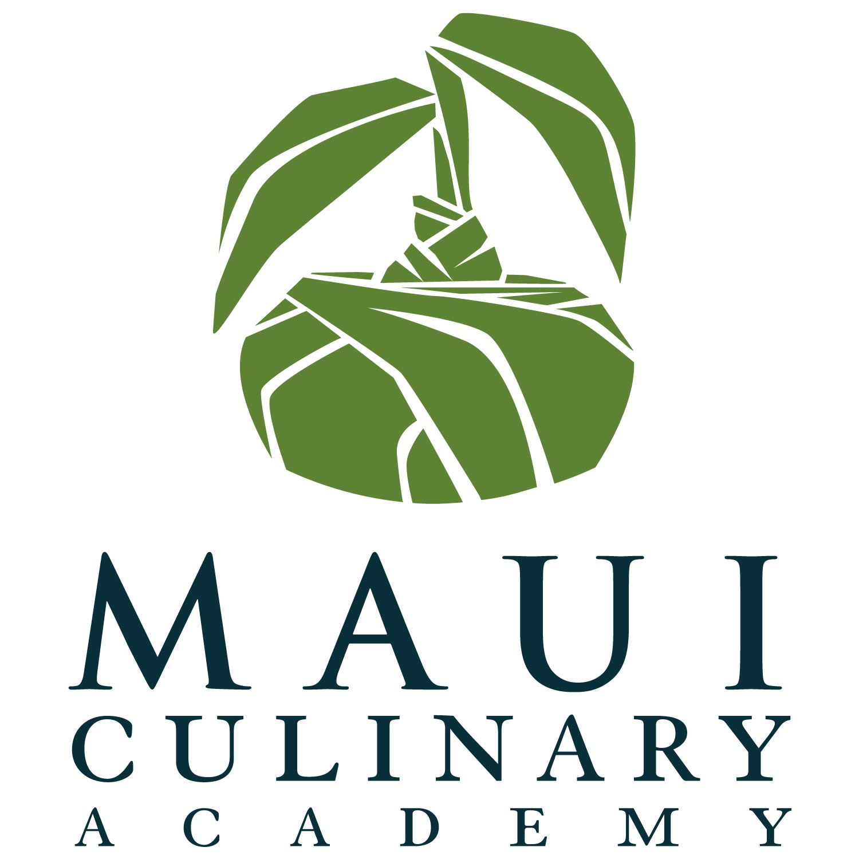

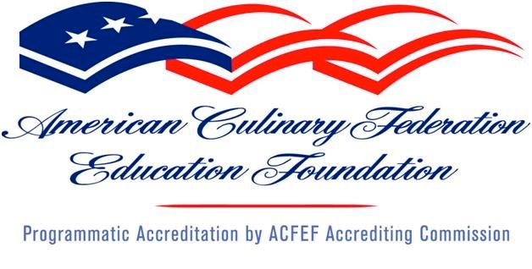

Prepared by Dean Louie, Assistant Professor & Program Coordinator
November 02, 2015

TABLE OF CONTENTS

Assessment of Student Learning 1
Assessment Form A: Program Learning Outcome (PLO) Report 2
Assessment Form B: Collegewide Academic and Student Learning
Outcome Report 3

Annual Degree Program Assessment Report Guidelines 4
Academic Affairs Budget Timeline 4

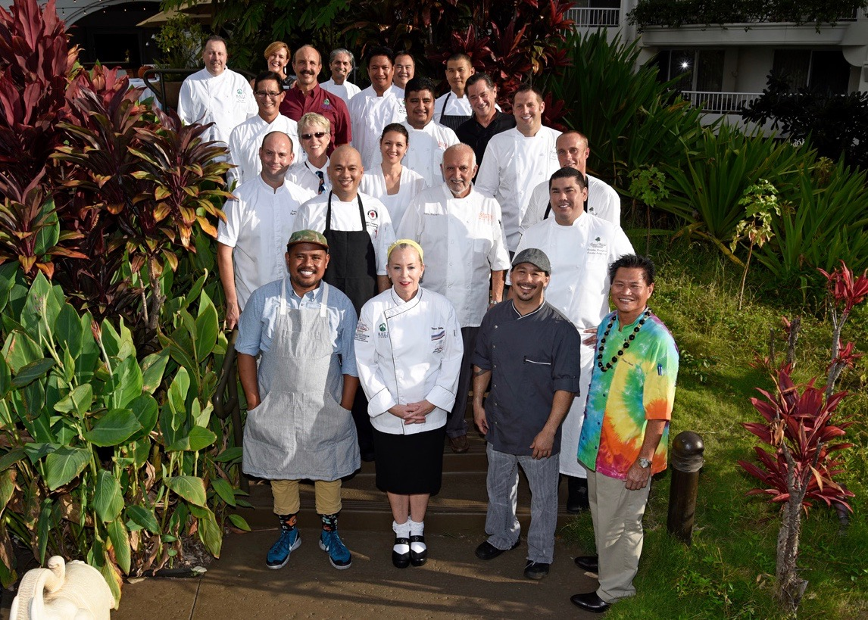
MCA Advisory Chefs and Faculty, Wailea, Maui, October 2015
Assessment of Student Learning

UH Maui College faculty members are expected to participate in assessment of the quality of learning taking place in UH Maui College degree programs. On-going assessment of College-wide Academic and Student Learning Outcomes (CASLO) and Program Learning Outcomes (PLO) rely on input from, students, community members, full-time faculty, and lecturers to help us determine how well each program of study meet our students’ authentic needs upon graduation. By helping us identify best practices and educational gaps, these practices support the continuous improvement of UHMC degree programs. The purpose of this handbook is to guide faculty in documenting the impact of this process on student learning.
This handbook provides three useful forms for annually documenting the assessment of student learning at UHMC. “Assessment Form A” is designed for documenting the results of PLO assessment. “Assessment Form B” is designed for documenting the results from CASLO assessment. Finally, “Annual Degree Program Assessment Report” is to be completed by each program coordinator to document the annual results of this assessment cycle.
The following timeline each degree program should be followed to gather the data to be included in Assessment Forms A and B.
- Establish an assessment map identifying the PLO that will be assessed during current and subsequent academic years (encourage each program to only select one PLO per year for assessment).
- During spring semester of the previous academic year, identify an exit level class for both PLO and CASLO assessment. < This works, we have been identifying this in the beginning of fall.
- During fall semester collect evidence of exemplary and minimally passing student work from both the course selected for PLO assessment and the course selected for CASLO assessment.
- In partnership with the CASLO and PLO assessment coordinators hold a meeting of your program advisory committee to review the student work samples.
- During spring semester complete Assessment Forms A and B documenting the results of the assessment meeting with your advisory committee.
The following timeline describes the steps associated with completing the Annual Degree Program Assessment Report:

- Assessment reports are due to the VCAA in early November.
- During November each program will share and discuss assessment reports and results with colleagues at the Department level.
- Liberal Arts faculty will hold a meeting in November to discuss assessment results for the Liberal Arts degree programs (AA, AA in Hawaiian Studies, and ASNS).
- Results will be shared and discussed at the December Department Chair and Program Coordinators meeting.

Assessment Form A: Program Learning Outcome (PLO) Report

Program Name: CULN, Maui Culinary Academy
Program Learning Outcomes: Please list your Program Learning Outcomes. Highlight the PLO this report is focused on.
Upon successful completion of the CULN Program, the student should be able to:
- Apply principles and concepts of quality food purchasing, food and baking preparation, service, and proper use of tools and equipment to produce and serve a variety of professional food items.
- Apply the basic principles of culinary service, organization, sanitation and safety in a foodservice operation to maintain the optimum health of the consumer.
- Demonstrate skills in various areas of the culinary hierarchy: human relations, leadership and personnel management, ethical decision making.
- Discuss the standards of restaurant regulations involving liquor protocol and health and safety regulations.
- 5. Practice standards in behavior, grooming and dress appropriate to culinary industry professionals.

Meeting with Program Advisory Committee (PAC) took place:
Wednesday 3:30PM-4:30PM October 28, 2015.
Who was present at the Advisory Committee meeting?
Please see attached meeting agenda and attendance list.

What student evidence was discussed as it relates to the PLO this report is focused on? Please attach if necessary. It may be helpful to discuss an “exceeds” example but even more important to discuss one that “minimally meets” accomplishment of the PLO (ie: “C” paper). Please write a summary of the discussion that took place with the Advisory Committee.

PLO 2: Instructor Tom Lelli described efforts of developing a comprehensive list of standard food service equipment assessing Maui Culinary Academy (MCA) students for safety and knowledge based on American Culinary Federation (ACF) accreditation competencies. These competencies are based on “Pass or Fail” grading, and shared with all lab faculty on program adopted LiveText online software.
The committee concurred that the consolidation of an equipment checklist was a necessary and relevant program endeavor for 2015 CULN Program Review, as well as the 2016 ACF Program Accreditation Report.

What best practices and educational gaps were identified though the discussion with the Advisory Committee?
In addition to comprehensively tracking ACF competencies of a Student Equipment Safety Checklist, Instructor Craig Omori explained new ACF sustainability competencies offered in Fall 2016.

As a result of assessment activities, what action will be taken? What changes, amendments, additions will be made to the PLO evidence, if any? Will the assignment change? Is the PLO still relevant to the field? How do you know?
Action Plan: The program will introduce Student Equipment Safety checklists for student competency for kitchen labs by Fall 2016. These new efforts will support our PLO’s and recognize ACF accreditation competencies by completion of Fall 2016.
The MCA program has adopted a CULN Program Coordination Council (PCC) curriculum with a new one (1) credit CULN 116 Sustainability course that addresses ACF sustainability measures for program accreditation compliance. Assignments will be developed to track CULN 116 student progress in Laulima and on LiveText.

Both additions/changes are relevant to the culinary arts industry. Worker safety knowledge is an ongoing priority in the hospitality industry due to increased liability and insurance. Sustainability, renewable resources and energy conservation are current economic trends in every industry.

Assessment Form B: College-wide Academic and Student Learning Outcome (CASLO) Report

Program Name: CULN, Maui Culinary Academy
Highlight the CASLO this report is focused on.
Quantitative Reasoning (QR)
Meeting with Program Advisory Committee (PAC) took place:
Wednesday 3:30PM-4:30PM October 28, 2015.
Who was present at the Advisory Committee meeting?
Please see attached meeting agenda and attendance list.

What student evidence was discussed as it relates to the CASLO this report is focused on? Please attach if necessary. It may be helpful to discuss an “exceeds” example but even more important to discuss one that “minimally meets” accomplishment of the CASLO (ie: “C” paper).
CULN QR CASLO statement was shared with PAC (attached)

Please write a summary of the discussion that took place with the Advisory Committee.
QR CASLO: Instructor Dan Schulte shared results of the Quantitative Reasoning CASLO assessment in history and in summation. Discussed were formative changes to 100 level college math courses required by UHMC’s WASC commission with Math Department collaboration. CULN 100 (3 CR) Math for CULN was developed by Schulte for the MCA Program. There is a specific textbook adopted and standard comprehensive final exam validating student knowledge and competency in the CULN 100 course.

What were the outcomes of the discussion with the Advisory Committee?

Current MCA students informed advisory members and teaching faculty of their personal experience in support of the new CULN 100 Math course relating to it’s effectiveness in relevant skills sets in: critical thinking, measurement conversion, recipe calculations and purchasing & cost control.

As a result of the discussion with the Advisory Committee, what action will be taken? What changes, amendments, additions will be made to the CASLO evidence, if any? Will the assignment change? Is the CASLO still relevant to the field? How do you know?
Action Plan: The CULN 100 Math for CULN course will continually maintain and track SLO’s, and ACF competencies for assessment. No changes in specific CASLO’s or assignments will be necessary at the current time.
The Quantitative Reasoning CASLO is still relevant to the hospitality industry. Basic entry, advanced and leadership positions require individuals to possess minimal skills in critical thinking, arithmetic, measurement conversion, portion calculation and cost control skills, as required in the workplace for efficiency, economics and advancement.

ANNUAL DEGREE PROGRAM ASSESSMENT REPORT

Overview
The emphasis of the report should be on PLO and CASLO assessment, action items emerging from those assessments, and a table listing the top three budget requests from each degree program. Bullet points are certainly acceptable for the sections requiring written responses. Finally, if you respond to the system data please keep each section (demand, effectiveness and efficiency) to 100 words or fewer. Also, you will notice a roman numeral in parenthesis by each item. The roman numerals indicate the corresponding system item number for when you upload you report to the system website.

Program Review preparation guidelines

Program Name: CULN- Maui Culinary Academy
Program Description: The Maui Culinary Academy is a comprehensive educational program established to prepare students for success in the hospitality industry in Hawaii and beyond. As an exceptional, nationally accredited American Culinary Federation Educational Institution (ACFEI), we offer Certificates of Achievement (CA), Certificates of Competency (CO), and Associates of Applied Science (AAS) degrees in Culinary Arts and Baking.

- Briefly respond in 100 words or less for each cautionary and/or unhealthy Quantitative Indicator (II):
The Instructional Annual reports of Program Data (ARPD) for UHMC Culinary Arts Program Quantitative indicators for 2015 overall program health are deemed “Healthy” for CULN. (See attached)
  - Demand Indicator: Cautionary. Our number of program majors has decreased from 2012-2015 (180>146) while industry demand has risen (560>632). We believe this is due to Hawaii’s economic increase in service and commerce, and historic low unemployment numbers. Our leadership goal is to demonstrate program quality through assessment practices, develop local area student recruitment, and continue working with industry partners to support workforce development, and maintain external funding to sustain student scholarship for those with hardships.

  - Efficiency Indicator: Healthy. Although we have healthy numbers, our efficiency and retention rates may be attributed to the reduced ratio of class sizes where students benefit from smaller classes and increased instructor time per student. We have also reduced the number of classes in the past years due to reduced enrollment that may provide a deceptive sense of efficiency.
  - Effectiveness Indicator: Healthy. Students have maintained greater completions with “C” or higher through stabilization of program remapping, consistency of instruction and increased certification (NRA ServSafe Sanitation, ManageFirst Purchasing and Cost Controls). A limited scholarship incentive program that required a “B” average in all courses per semester may have affected rates. Greater persistence rates may have increased due to greater amount assessment and the support provided to students.

ARPD Overall Program Health URL: https://www.hawaii.edu/offices/cc/arpd/instructional.php?action=quantitativeindicators&college=MAU&year=2015&program=124
Industry Validation (check all that apply)(IV-A):
Advisory Committee Meeting(s) X, How many? 2 Did Advisory Committee discuss CASLO/PLO? Yes X No_Coop Ed Placements X Fund raising activities/events X Service Learning X
Provide program services that support campus and/or community X Outreach to public schools X
Partner with other colleges, states and/or countries X Partner with businesses and organizations X
Other:

As one of UHMC’s progressive, visible and publically recognized programs, the Maui Culinary Academy gains robust support from our culinary arts industry to offer professional experience for students and sustain annual fundraising efforts for the benefit of higher education. The program also offers community support in distance–learning for disadvantaged communities, several cultural programs throughout the year and hosts tours and activities for area schools.

- List PLOs (Attach Assessment Form A)(IV):
 | CULN 111 | CULN 112 | CULN 115 | CULN 120 | CULN 123 | CULN 150 | CULN 160 | CULN 220
PLO 1 | 2 |  | 2 | 2 | 2 | 2 | 2 | 3
PLO 2 |  | 2 | 2 | 2 | 2 | 2 | 3 | 2
PLO 3 | 2 | 1 | 2 | 2 | 2 | 2 | 3 | 3
PLO 4 | 1 | 2 | 2 |  |  |  | 2
PLO 5 | 1 | 2 | 2 | 2 | 2 | 2 | 3 | 2
 | CULN 240 | CULN 250 | CULN 251 | CULN 271 | CULN 292V | CULN 293V
PLO 1 | 3 | 3 | 3 | 2 | 2 | 2
PLO 2 | 2 | 2 | 2 | 3 | 2 | 3
PLO 3 | 2 | 2 | 2 | 3 | 1 | 2
PLO 4 |  |  |  | 2 | 2 | 1
PLO 5 | 3 | 3 | 3 | 2 | 2 | 2

- Instrument used for assessment (check all that apply) (IV-B):
Work Sample X Portfolio X Project X Exam X Writing Sample X Other__ Please explain:

- In addition to analog assessment, the CULN program uses the UH Laulima online management system for digital assignment. Since 2012, the MCA program has been implementing comprehensive program assessment though LiveText assessment software for performance review and accreditation. We are currently integrating a cumulative student E-Portfolio in specific courses that capture and demonstrate student knowledge and skill sets for workforce development.

- Which course or courses did you use to assess PLOs and CASLO (IV-C)?

PLO 2: CULN 220 (5 CR), Advanced Cookery
CASLO QR: CULN 100 (3 CR), Math for CULN

- List strengths and weaknesses found from PLO assessment analysis (IV-E):

Strength: Instructor Tom Lelli has shared a standard rubric in LiveText to measure student knowledge in assessing specific kitchen equipment safety for UHMC students in his 220 classes. This is a pass or fail assessment that is easily replicable.

Weakness: To assess student knowledge and safety, culinary and baking instructors will need to adopt this equipment safety rubric so the program can collect the data to validate ACF accreditation compliance.

- List CASLO assessment findings highlights (attach CASLO report) (IV-E):
LAULIMA CASLO Culinary--Quantitative Reasoning CASLO Report
: URL: https://laulima.hawaii.edu/portal/site/91ea6bed-23da-449e-8af8-76659235c891/page/397028c4-6415-488e-9ceb-9b54dff72f01

- Action Plan (III) and Next Steps (IV-G):
  - PLO: Adopt equipment safety rubric in kitchen lab courses by Fall 2016. Require CULN 116 Culinary Sustainability for ACF student competency. Program will collect the data to validate annual ACF accreditation compliance.
  - CASLO: Quantitative Reasoning. Offer Teaching & Learning Center (TLC) instruction and assignment assistance targeted for Spring/Fall 2016.
  - Program improvement: Enhance program value with LiveText E-portfolio project. Pool Laulima assessment resources into LiveText to collate overarching program data for improvement. Increase program capability to capture ACF accreditation competencies for student equipment checklists and sustainability in CULN 116 (Fall 2016).

- List of top three resource requests (IV)

Budget request | Amount | In 100 words or less describe how does this request relate to the strategic plan | If outside of the Strategic Plan provide rational for the request (in 100 words or less).
CULN Required Equipment | $30,000 | Equipment repair, equipment replenishment and necessary maintenance for faculty teaching, student learning and requisite State of Hawaii health and safety regulations. | State of Hawaii Health Department Food Safety Permit and ACF Accreditation Requirements
Replacement table fixtures for three Pa'ina lecture rooms | $30,000 | Establishment of moveable and flexible furniture will increase interactivity and productivity in learning circles during instruction. | As mentioned in Morton's refurbishment to 21st C learners F14. ACF Accreditation Report
Minor refurbishment of UHMC Pa'ina flagship restaurant. | $25,000 | Redesign of basic elements, fixtures and surfaces will streamline energy, operations and student learning. This will place the teaching courses and labs to levels of instruction that correlate to current industry models. | As mentioned in Morton's refurbishment to 21st C learners F14. ACF Accreditation Report

* Roman numerals indicate related category for system input

Academic Affairs Budget Timeline
- September: Programs, Disciplines and Service areas select 3 budget items
- October: Items vetted by Unit resulting in a prioritize list of ten items
- November: Items shared among Academic Affairs
- December: Academic priorities finalized
MCA Advisory Committee Updates Fall 2015
Wednesday October 28, 2015
3:30PM-4:30PM Pa’ina 236
New Business & Agenda
Advisory Committee: Diane Woodburn MNKO Mag, Paula Hegele Maui Wine, Lyndon Honda Laulima Catering, Tim Pagan HFM, Rick Woodford Island Restaurant Concepts, Craig Erickson Diamond Resorts.
Faculty: Teresa Shurilla, Craig Omori, Tom Lelli. Juli Umetsu, Dan Schulte, Jake Belmonte, Christine Pafford, Mike Umetsu, Karen Robbins, Kulamanu Ishihara
Jan Moore DC, John McKee VCAA. MCA Alumnus: Beverly Karagianes, Susan Peck, Stevie-Ray Walker
Dean Louie MCA Program Coordinator
Introduction Roundtable
Changes and Information:
- Chris Speere transition to lead Food Innovation Center, July 2015
- Lecturer Position open for Spring 2016: CULN 120 Fundamental Cookery
- 5-year Managed Services Contract (Sodexo) Doug Paul, Manager
External
- Noble Chef Event Feedback; Est $135K revenue/$35K Expenses ($20K MNKO!)
- New Involvement in Culinary Competition: Chaine De Rotisseurs, Into-the-Fire (DOE), ACF Culinary Competitions
Instructional
- Job Corps Articulation: 12 credits with completion of Culinary certificate
- 11/19 Garde Manger Market event 5PM
- 12/09 Aipono Dinner LFCA 6PM
- Request for PT Purchasing Clerk
- CULN 116 (2CR), Sustainability Class Fall 2016
Internal
- UHMC Program Review due Nov 02
- ACF Program Review Due Feb 1
- Student Tech Fee approval on replacing Lecture Room computers and projectors

Fall 2015 updates:
- 09/10/15 DOH Inspection recorded two violations to be adjusted: refer door gaskets and consumer advisory. Permit approval pending with re-inspection.
- 9/21-22/15 Hosted CCSF Culinary Program for LiveText assessment practices
- 9/29/15 Maui Job Corps Articulation agreement approved
- 10/07/15 Request for PT purchasing clerk to David Tamanaha VCAA
- 10/08/15 replacement iMac desktops and 2 laser projectors submitted and approved for purchase through Student Tech Fee Committee/IT

Program activity:
08/21 Ai’pono Wine Dinner at Andaz Resort (Dean, 4 participating students)
09/2-6 Hawaii Food and Wine Festival at Ka’anapali (Dean/15 participating students)
09/08 CIP Ground Breaking/PCC Meeting, KCC (Dean, represented)
09/11 DOE Counselors Day, Cookie Decorating Demo (Cheech)
09/18 Kamehameha 8th Grade Tour 108 / 4 tours of students (Dean)
09/18 American Cancer Society Benefit at Maui Brewing (6 participating students)
10/01 Maui Job Corps Meeting and Tour (Dean)
10/06 Ritz-Carlton Resort Kapalua, Microsoft Event 700 PAX (6 participating students)
10/15 Ai’pono Wine Dinner at Westin Ka’anapali Ocean Resort (Dean, 7 participating students)
10/16 UHCC Board of Regents Visit and LiveText Demo (Christine/Dean)
10/17 Fil-Am Cooking Competition, Maui Mall (Jake and students)
10/17 Noble Chef Event, Fairmont Kea Lani (Program Event)
10/23 Food Summit II @ KCC (Dean)
Remaining program activities
10/28 MCA Advisory Committee Meeting 3:30
11/06 Sake & Stevo Benefit for their Sous Chef, Makena Resort (no commitment)
11/14 Hui No’eau Annual Art Fest, Hotel Wailea (no commitment)
11/19 Garde Manger Market event (Craig/Rod)
11/25 Kamehameha Schools, Maui, Career Day
12/09 Aipono Dinner LFCA (Juli, Tom)

2015 MCA Advisory Council Members
October 28, 2015 Attendees
- Chef Lyndon Honda, Laulima Catering
- Rick Woodford, Island Restaurant Concepts Consulting
- Paula Hegele: Maui Wine
- Chef Tylun Pang: Fairmont Kea Lani Maui
- Diane Haynes Woodburn: Maui No Ka Oi Magazine
- Craig Erickson, Diamond Resorts Ka’anapali
- Stevie-Ray Walker: MCA Student Representative
- Noelle Bendell, MCA Student Representative
- *Susan Peck, MCA Alumnus
- Beverly Karagianes, MCA student
- Tanya Doyle, MCA student
- *Clarissa Logsdon, MCA Alumnus
- Doug Paul, GM Sodexo
- Tom Lelli, MCA Faculty
- Craig Omori, MCA Faculty
- Juli Umetsu, MCA Faculty
- Dean Louie, MCA Program Coordinator
* MCA Student Graduates

