2016-17 Program Review
Program Name: Applied Business and Information Technology (ABIT)
- Program Description
The Applied Business and Information Technology (ABIT) program prepares graduates to be successful entrepreneurs, technology professionals and knowledge workers in today’s global economy and environment. The ABIT program is within the mission of the UH Maui College, offering a four-year degree that emphasizes high quality instruction and project-based learning.
Currently, the ABIT program offers both lower and upper-division courses to all students. The ABIT program serves a diverse student population, many of who are first genera􀆟on college students. The program also adjusts to traditional and non-traditional students, many of whom hold part-time jobs while completing their educational degree. The ABIT program is structured so that students can complete their entire degree over a four-year period. However, many students take longer to complete this degree based on personal and professional constraints and commitments.

- Briefly respond for each cautionary and/or unhealthy Quantitative Indicator (II):
  - Demand Indicator: Data indicates Cautionary – significant increase in majors and SSH for 2016-2017

  - Effectiveness Indicator: Data indicates Cautionary – significant increase in class size and majors to FTE BOR

  - Efficiency Indicator: Data indicates Healthy – increase in Completion rates, steady Persistence Fall-Spring

ANALYSIS
Analysis of the Program
- Briefly discuss any new significant program actions (new certificates, stopout, gain or loss of positions) as results of last year’s action plan.
n/a
- If relevant, share a brief analysis for any Perkins Core Indicator not met.
n/a
- Goals and/or actions from previous assessment results
- Describe results from previous assessment goal and/or action implementation

  - PLO

- The ABIT Capstone I and II course (BUS 495 and 496) will be used every year to assess all 9 PLOs
- The Entrepreneurship course BUS 320 will form an anchor or prerequisite to BUS 495 course
- Every upper division ABIT course will assess at least one ABIT PLO every year
- The mandatory internship course BUS 393v will also support the progress towards BUS 495
- Finally, the ABIT PLOs need to be reviewed by the ABIT Advisory board and updated, if needed

  - CASLO
Revision of the course syllabus – The ABIT Capstone I syllabus needs changes to focus on the CASLO for the year. This can be achieved by including more learning modules on the creation of financial equation and their analysis and presentation to entrepreneurs.
Faculty-to-faculty consultation – The ABIT Capstone I project is a culmination of student learning across a variety of disciplines throughout the ABIT program. As a result, there needs to be ongoing consultant among ABIT faculty members to ensure that students are adequately prepared prior to BUS 495.
P-SLOs TAB
- PLO selected for assessment (click on the PLO assessed – it will turn green).

- Industry Validation (check all that apply):

Advisory Committee Meeting(s) _x_, How many? _6 per AY_
Did Advisory Committee discuss CASLO/PLO? Yes_x_ No__
Coop Ed Placements __ Fund raising activities/events __ Service Learning __
Provide program services that support campus and/or community
Outreach to public schools _x_
Partner with other colleges, states and/or countries _x_
Partner with businesses and organizations _x_
Other_x_ Describe_______________________________________________________________

- Expected level of Achievement:
For the PLO assessed, __ % of students completing the assignment/course expected to meet expectations for the assignment/course.
- Courses (or assignments) Assessed:
BUS 495 Capstone I and BUS 496 Capstone II

- Assessment strategy/Instrument/Evidence (check all that apply):
Work Sample_x_ Portfolio__ Project _x_ Exam __ Writing Sample __
Other__ Please explain_________________________________________________

- Results of program assessment:
  - The following were present at the PLO assessment: ABIT Faculty, ABIT Advisory Board
  - Strengths and weaknesses (best practices and educational gaps) found from PLO assessment analysis.
An assessment rubric will be used for the Capstone I (495) and II (496) courses. The end-of-course BUS 495 capstone evaluation, along with other assignments during the two capstone courses, will allow the ABIT program to assess all nine PLOs every year
The ABIT advisory committee will review the assessment data every six months, and provide feedback to the ABIT faculty on program modification and curriculum updates
Coordinated marketing and recruitments activities to increase enrollment levels in the ABIT program, and to retain existing students in the program
Increased outreach activities to local Maui County high schools to increase awareness and interest in the new four-year ABIT program. This includes Lanai and Molokai
- Other comments: n/a
Describe CASLO assessment findings and resulting action plans. Go to Laulima UHMC CASLO Assessment for your program’s “Assessment results” and summarize below.

CASLO assessment findings | Action plan to address findings
n/a – not assessed for AY 2017-18

- Next steps: n/a
For program learning outcomes (check all that apply):
Assess the next PLO___ Review PLOs___ Adjust assignment used for PLO___
Adjust course used for PLO___ Meet with Advisory Committee____
Other___ Please explain:

- Please list any professional development needs you may have for your program. n/a

System website:
http://www.hawaii.edu/offices/cc/arpd/instructional.php?year=2015&action=quantitativeindicators&college=HAW
Select Maui College and your program in the drop down menus.
On the page that shows the Quantitative indicators, click on “web submission”.
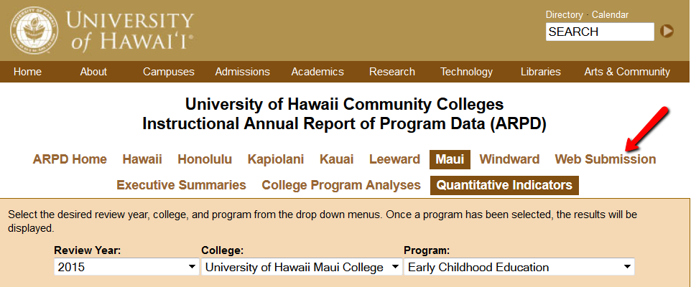

You’ll log in on the next page.
When the page with tabs comes up, click on Analysis tab.
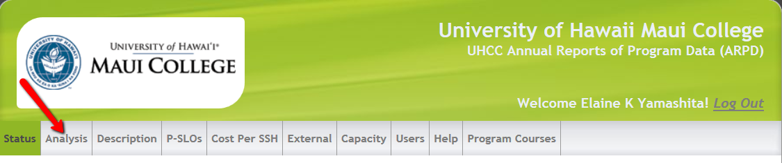

Click on “edit”. Copy and paste from this document into each section. If you are pasting from Word, you need to click on the “W” icon and then paste into the box that pops up (like in Laulima). See green arrow below.
REMEMBER TO “SAVE” EACH SECTION! (red arrow in pic below).

You’ll be entering information into:
- Analysis
- Description
- P-SLOs
- External (if your program has an external exam)

REMEMBER TO SAVE (red arrow) EACH SECTION!


